Personal Application Proposal

**Name:** Hansen Muhile

**Date:** 7/6/2020

# Description of Personal Application

My personal application would be one that helps solve the problem of renting outdoor gear for college students. I am going to solve this by providing an application that show availability of outdoor gear and price for renting it. When the client uses the app, they can search for the gear they want and it would show them if it is available or not and if it is, they can rent it by signing up using their I.D number provided by the school and the price will be charged on their school account when they check the item out.

# Design of Your Application

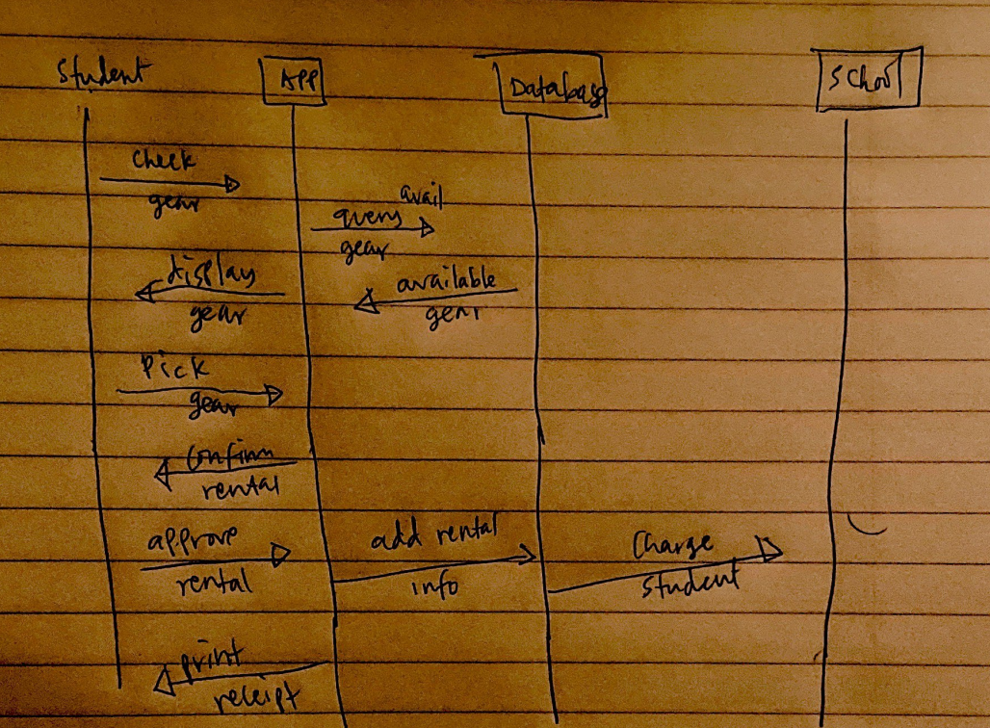

# Topics Incorporated into Your Application

* Hibernate
* Servlet
* JSON
* Collections